Grand Finale Different Rules:

* Each game is now a best-of-5 (first to 3)
* Each win is worth one point on the ladder
* When there is an ‘And-one’, the player who got fouled has the option to also take a free throw (an extra point). If they take the free throw, typical rules apply however (if they miss the other team gets the ball)
* Any intentional dirty play is a technical foul on the player. A technical foul counts as two individual fouls. The person fouled is allowed one free throw, and whether they make or miss, their team regains the ball afterwards.
* Whenever your team is resting, place make sure you are watching the game to call fouls that are iffy (this is specifically targeted to the GM’s)
* If at the end of all the games, the difference between first and second OR second and third is less than 1.5 points (1 point, 0.5 points, or 0 points), the two teams will play a first-to-7 **(not a best-of-7)** to determine the tournament winner (or, in the case of second/third, they will play to determine who plays in the Grand Finale)
  + The team that is placed higher on the ladder starts with the ball
    - If the teams are tied, we go through tiebreakers: (record from the GF, head-head, all-season head-head)
  + There will be 1 minute rest before each placing game
  + 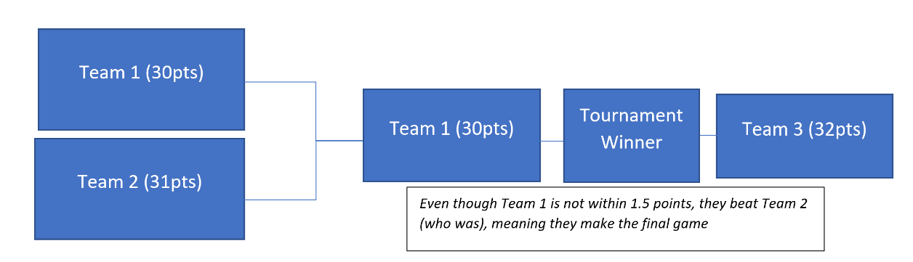If, somehow, the third place team beats the second place team to play in the final game, but they are not within 1.5 points of first, they will still play, as long as second place was within 1.5 points of first (explained below in the diagram)
  + Theoretically, this means a team that is 2 points behind first can still win the tournament
* Each team receives two timeouts over the day, and one in any placing game